**Online Food Ordering**

A Minor Project report submission for the partial fulfilment of the requirement for the award of the degree

**MCA AI (Artificial Intelligence)**



**Submitted By:**

Nishita Saini

(235/PCA/017)

Prachi

(235/PCA/019)

Shubham Kumar Yadav

(235/PCA/025)

**Under the supervision of**

Mr. Kamala Kant Yadav

Assistant Professor

**To The**

DEPARTMENT OF INFORMATION TECHNOLOGY

SCHOOL OF INFORMATION AND COMMUNICATION TECHNOLOGY

GAUTAM BUDDHA UNIVERSITY

DECEMBER 2024



SCHOOL OF INFORMATION AND COMMUNICATION TECHNOLOGY

GAUTAM BUDDHA UNIVERSITY, GREATER NOIDA, 201312, U. P.(INDIA)

**Candidate’s Declaration**

|  |  |  |
| --- | --- | --- |
| **NAME: -** | **ROLL NO.: -** | **SIGNATURE: -** |
| Nishita Saini | 235/PCA/017 |  |
| Prachi | 235/PCA/019 |  |
| Shubham Kumar Yadav | 235/PCA/025 |  |

We, hereby, certify that the work embodied in this project report entitled “Online Food Ordering” in partial fulfilments of the requirements for the award of the degree of MCA AI (Artificial Intelligence). Submitted to the School of Information and Communication Technology, Gautam Buddha University, Greater Noida, is an authentic record of our own work carried out under the supervision of **Mr. Kamala Kant Yadav Assistant Professor**, School of ICT. The matter presented in this report has not been submitted in any other University / Institute for the award of any other degree or diploma. Responsibility for any plagiarism related issue stands solely with us.

This is to certify that the above statement made by the candidates is correct to the best of my knowledge and belief. However, responsibility for any plagiarism related issue solely stands with the students.

Signature of the Supervisor:

Name with Designation: ……………………………….

Date: Place: Gautam Buddha University, Greater Noida

**Acknowledgement**

We have taken efforts in this project. However, it would not have been possible without the kind support and help of many individuals and organizations. I would like to extend my sincere thanks to all of them.

We are highly indebted to **Mr. Kamala Kant Yadav Assistant Professor** for his guidance and constant supervision as well as for providing necessary information regarding the project and also for her support in completing the project.

We would like to thank Dean of ICT **Dr. Arpit Bhardwaj**, and HOD of IT, **Dr. Neeta Singh** whose work helped us to complete our project. We would like to express our gratitude towards our friends & family member for their kind co-operation and encouragement which help me in completion of this project.

I am grateful to all the individuals who have contributed to this report in various ways, directly and indirectly. Their support and encouragement have been invaluable.

Thank you.

**Abstract**

The online food ordering industry has experienced significant growth, driven by changing consumer preferences and advances in technology. This project focuses on the development of a comprehensive online food ordering platform that caters to the needs of both customers and restaurant owners. By providing an intuitive interface, the platform enables users to easily browse menus, customize their meals, and place orders with minimal effort. This convenience encourages users to explore a variety of dining options, enhancing their overall experience.

To ensure a seamless interaction, the platform integrates features such as secure payment processing, real-time order food and user feedback. These functionalities not only streamline the ordering process but also build trust and transparency between consumers and food providers. Additionally, the incorporation of personalized recommendations based on user preferences aims to enhance customer satisfaction and encourage repeat business.

For restaurant partners, the platform offers robust management tools that facilitate order processing, inventory tracking, and performance analytics. This empowers restaurants to optimize their operations and respond effectively to customer demands. By bridging the gap between consumers and local eateries, this online food ordering system contributes to the growth of the digital dining landscape, promoting a more efficient and enjoyable food delivery experience for all stakeholders involved.

|  |  |  |  |
| --- | --- | --- | --- |
| **INDEX** | | | |
| **Sr No.** | **Particulars** | | **Page No.** |
| **1.** | **Introduction** | |  |
| **1.1** | **Introduction** | **06** |
| **1.2** | **Project Objective** | **06** |
| **1.3** | **Scope of Project** | **07** |
| **1.4** | **Challenges** | **07** |
| **2.** | **Development Environment** | |  |
| **2.1** | **Development Tools (Software Requirement and Hardware Requirement)** | **08** |
| **2.2** | **Development Strategy (Process Model)** | **16** |
| **3.** | **System Analysis** | |  |
| **3.1** | **Requirement Gathering & Analysis** | **20** |
| **3.2** | **Scope of the System** | **21** |
| **4.** | **Software Requirement specification** | |  |
| **4.1** | **E-R Diagram** | **23** |
| **4.2** | **System Flow Diagram** | **24** |
| **4.3** | **Data Flow Diagram** | **25** |
| **5.** | **Advantage of online food order** | | **27** |
| **6.** | **Screenshots** | | **28** |
| **7.** | **Conclusion** | | **36** |
| **8.** | **Future Scope** | | **37** |
| **9.** | **References** | | **38** |

1. Introduction

#### **Introduction:**

In today’s fast-paced world, the demand for convenient dining solutions has surged, making online food ordering an integral part of modern consumer behaviour. This project aims to develop an online food ordering platform that simplifies the process of ordering meals from various restaurants, enhancing customer experience while providing efficient service to food vendors.

The proposed system will offer a user-friendly interface that allows customers to browse a wide range of restaurants, view menus, customize their orders, and make secure payments. With real-time tracking, users can monitor their order status from preparation to delivery.

#### **Objective:**

The online food ordering system is to create a user-friendly platform that allows customers to conveniently browse, select, and order food from their favourite restaurants. The system aims to streamline the process of food ordering by providing the following features:

* **User-Friendly Interface:** Create an intuitive platform for easy browsing, order customization, and seamless purchases.
* **Real-Time Order Tracking:** Provide users with updates on order status from preparation to delivery for enhanced transparency.
* **Restaurant Management System:** Develop an interface for restaurant managers to efficiently manage orders, menus, inventory, and sales data.
* **User Account Features:** Allow users to create and manage accounts with order history, saved payment methods, and personalized recommendations.
* **Mobile Compatibility:** Ensure full responsiveness and functionality on mobile devices for users who prefer ordering via smartphones and tablets.
* **Promotional Offers and Discounts**: Enable restaurants to apply promotions and discounts to encourage loyalty and increase sales.
* **Data Security and Privacy:** Implement robust security measures to protect user data and comply with regulations.
* **Feedback and Rating System:** Establish a mechanism for customers to provide feedback and rate their experiences, aiding service improvement.

#### **Scope of Project:**

The online food ordering system project aims to create a platform for users to order food from various restaurants via a web-based and mobile application. It will cater to both customers and restaurant managers with distinct features for each group.

* **Customer Interaction**: Users can browse menus, customize orders, and place them online securely with multiple payment options. Real-time order tracking, account creation, order history, and personalized promotions will enhance the experience.
* **Restaurant Management**: Restaurants will have an interface to manage orders, update menus, handle inventory, and apply discounts. They can track order statuses, adjust delivery times, and access sales reports for better performance. The system will support multiple branches.
* **Technical Features**: The project includes mobile apps for Android and iOS and a web platform accessible via browsers. It will integrate secure payment gateways and be designed to scale with a growing user base. Third-party delivery services will be used for fulfilment.

#### **Challenges:**

**1. Scope Creep**

* Challenge: Occurs when new features are added without adjusting time, budget, or resources.
* Solution: Clearly define the project scope at the beginning and regularly manage any changes.

**2. Technical Difficulties**

* Challenge: Bugs and integration problems may arise during development.
* Solution: Conduct thorough testing and maintain a solid troubleshooting plan.

**3. Resource Management**

* Challenge: Ensuring availability of skilled developers and adequate budgets.
* Solution: Plan resource allocation carefully and monitor usage throughout the project.

**4. Security Concerns**

* Challenge: Protecting user data from cyber threats.
* Solution: Implement robust security measures, such as SSL certificates and data encryption.

**5. Integration with Third-Party Services**

* Challenge: Compatibility issues when integrating with payment gateways and other services.
* Solution: Choose well-documented services and thoroughly test integrations.

**6. Maintaining Performance**

* Challenge: Ensuring good performance during high traffic.
* Solution: Optimize code and use performance monitoring tools to identify bottlenecks.

1. DEVELOPMENT Environment

**2.1 Development Tools (Software Requirement and Hardware Requirement)**

To implement the project, there is requirement of different hardware and software. The main components for the Online Food Ordering are:

**Table 1: Software Requirements**

|  |  |  |
| --- | --- | --- |
| **S.NO** | **Software** | **Use** |
| **1.** | **OPERATING SYSTEM** | Windows 11. |
| **2.** | **FRONT-END** | HTML, CSS, JAVASCRIPT and BOOTSTRAP. |
| **3.** | **BACK-END** | PHP. |
| **4.** | **DATABASE** | MYSQL. |
| **5.** | **HELP TOOL** | XAMPP and VISUAL STUDIO. |

**Table 2: Hardware Requirements**

|  |  |  |
| --- | --- | --- |
| **S.NO** | **Hardware** | **Use** |
| **1.** | **PROCESSOR** | AMD RYZEN 5. |
| **2.** | **RAM** | 8GB |
| **3.** | **DISK** | 255GB SSD and 1TB HDD |
| **4.** | **DATABASE** | MYSQL. |

**PROGRAMMING LANGAUGE**

1. **PHP:**

**PHP is platform independent application made it can be run on way operation system such as windows8, XP, UNIX.**

What is PHP?

PHP is widely used general purpose scripting language that is especially suited for web development and can be embedded into HTML.



* + - PHP Stands for PHP: Hypertext Pre-processor
    - PHP is a server-side scripting language, like ASP
    - PHP scripts are executed on the server
    - PHP supports many databases (MySQL, Informix, Oracle, Sybase, solid, PostgreSQL, Generic ODBC, etc.)

###### PHP is an open source software

###### PHP is free to download and use

### **What is PHP File?**

* + - PHP files can contain text, HTML tags and scripts
    - PHP files are returned to the browser as plain HTML
    - PHP files have a file extension of “.php”,”.php3”, or “.phtml”.

**Why PHP?**

* PHP runs on different platform (Windows, Linux, Unix, etc.)
* PHP is compatible with almost all servers used today (Apache, IIs, etc.)

PHP is free to download from the official PHP resource: [www.php.net](http://www.php.net/) PHP is easy to learn and runs efficiently on the server side.

**XAMPP**

**Introduction to XAMP**

XAMPP is a cross-platform web server that is free and open-source. XAMPP is a short form for Cross-Platform, Apache, MySQL, PHP, and Perl.

* XAMPP is a popular cross-platform web server that allows programmers to write and test their code on a local webserver.
* It was created by Apache Friends, and the public can revise or modify its native source code.
* It includes Maria DB, Apache HTTP Server, and interpreters for PHP and Perl, among other computer languages. Because of XAMPP’s simplicity of deployment, a developer can quickly and easily install a WAMP or LAMP stack on an operating system, with the added benefit that common add-in apps like WordPress and Joomla can also be loaded.

**Need for XAMPP**

* XAMPP is simply a local host or server.
* This local server runs on your personal computer, whether it’s a desktop or a laptop.
* It is used to test clients or websites before publishing them to a remote web server.
* On a local computer, the XAMPP server software provides a suitable environment for testing MYSQL, PHP, Apache, and Perl projects. Because most real-world web server deployments share the same components as XAMPP, moving from a local test server to a live server is straightforward.

**ADVANTAGES AND DISADVANTAGES OF XAMPP**

**ADVANTAGE:**

* In comparison to other web servers such as WAMP, it is simple to set up.
* It is Multi Cross-Platform, which implies it works on both Windows and Linux.
* With a single command, you may start and stop the entire web server and database stack.
* Both a full and a standard version of XAMPP are available.
* It has a control panel that you can see contains start and stop buttons for specific mechanisms, such as Apache, which is running through its Control Panel.
* It also includes OpenSSL, phpMyAdmin, Media Wiki, Joomla, WordPress, and a lot of additional modules.

**DISADVANTAGES**:

* In comparison to the WAMP server, configuration and setting are more difficult.

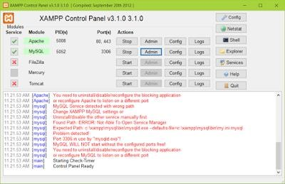

* PHP MY ADMIN

**What is PHP My Admin?**

* PHP My Admin is a free software tool written in PHP, intended to handle the administration of MySQL over the worldwide web.
* PHP my admin supports a wide range of operations with MySQL. The most frequently used operations are supported by the user interface (managing database, tables, fields, relation indexes, users, permission etc.)
* While you still have the ability to directly execute any SQL statement.

**History**

* Tobias Rat schiller, then an IT consultant and later founder of the software company Maguma, started to work on a PHP-based web front-end to MySQL in 1998, inspired by MySQL Web admin. He gave up the project (and php Ads New, of which he was also the original author) in 2000 because of lack of time.
* By that time, phpMyAdmin had already become one of the most popular PHP applications and MySQL administration tools, with a large community of users and contributors. In order to coordinate the growing number of patches, a group of three developers registered the phpMyAdmin Project at Source Forge and took over the development in 2001.
* In July 2015, the main website and the downloads left Source Forge and moved to a content delivery network. At the same time, the releases began to be PGP-signed. Afterwards, issue tracking moved to GitHub and the mailing lists migrated. Before version 4, which uses ajax extensively to enhance usability, the software used HTML frames.

**Features:**

* Web interface
* MySQL and MariaDB database management
* Import data from CSV and SQL
* Export data to various formats: CSV, SQL,XML,PDF(via the TCPDF library), ISO/IEC 26300 Open Document Text and Spreadsheet, Word, Excel, LaTeX and others
* Administering multiple servers
* Creating PDF graphics of the database layout
* Creating complex queries using query-by-example (QBE)
* Searching globally in a database or a subset of it transforming stored data into any format using a set of predefined functions, like displaying BLOB-data as image or download-link.
* Live charts to monitor MySQL server activity like connections, processes, CPU/memory usage, etc.

1. **JavaScript:**

JavaScript is a dynamic computer programming language. It is lightweight and most commonly used as a part of web pages, whose implementations allow client-side script to interact with the user and make dynamic pages. It is an interpreted programming language with object-oriented capabilities.



**History of JavaScript:**

In 1993, Mosaic, the first popular web browser, came into existence. In the year 1994, Netscape was founded by Marc Andreessen. He realized that the web needed to become more dynamic. Thus, a 'glue language' was believed to be provided to HTML to make web designing easy for designers and part-time programmers. Consequently, in 1995, the company recruited Brendan Eich intending to implement and embed Scheme programming language to the browser. But, before Brendan could start, the company merged with Sun Microsystems for adding Java into its Navigator so that it could compete with Microsoft over the web technologies and platforms. Now, two languages were there: Java and the scripting language. Further, Netscape decided to give a similar name to the scripting language as Java's. It led to 'JavaScript'. Finally, in May 1995, Marc Andreessen coined the first code of JavaScript named 'Mocha'. Later, the marketing team replaced the name with 'LiveScript'. But, due to trademark reasons and certain other reasons, in December 1995, the language was finally renamed to 'JavaScript'. From then, JavaScript came into existence. The ECMA-262 Specification defined a standard version of the core JavaScript language.

* JavaScript is a lightweight, interpreted programming language.
* Designed for creating network-centric applications.
* Complementary to and integrated with Java.
* Complementary to and integrated with HTML.
* Open and cross-platform.

1. **Bootstrap:**

Bootstrap is designed to help developers create responsive and mobile-first websites efficiently. It provides a collection of HTML, CSS, and JavaScript tools for building web pages and web applications. Bootstrap includes design templates for typography, forms, buttons, tables, navigation, modals, image carousels, and many other components, making it easier to develop consistent and visually appealing web interfaces. The framework was initially developed by Mark Otto and Jacob Thornton at Twitter to maintain consistency across internal tools and has since become one of the most popular front-end frameworks in the world



**Why Use Bootstrap?**

* **Mobile first approach** − Bootstrap 5, framework consists of Mobile first styles throughout the entire library instead them of in separate files
* **Logo

  Description automatically generatedBrowser Support** − It is supported by all popular browsers.
* **Easy to get started** − With just the knowledge of HTML and CSS anyone can get started with Bootstrap. Also the Bootstrap official site has a good documentation.
* A picture containing icon

  Description automatically generated**Responsive design** − Bootstrap's responsive CSS adjusts to Desktops, Tablets and Mobiles.
* Provides a clean and uniform solution for building an interface for developers.
* It contains beautiful and functional built-in components which are easy to customize.
* It also provides web based customization.
* And best of all it is an open source.

1. **Visual Studio Code:**

Visual Studio Code is a source-code editor that can be used with a variety of programming languages, including Java, JavaScript, Go, Node.js, Python and C++.

It is based on the Electron framework, which is used to develop Node.js Web applications that run on the Blink layout engine.

Visual Studio Code employs the same editor component (codenamed "Monaco") used in Azure DevOps (formerly called Visual Studio Online and Visual Studio Team Services).

Out of the box, Visual Studio Code includes basic support for most common programming languages. This basic support includes syntax highlighting, bracket matching, code folding, and configurable snippets.

Visual Studio Code also ships with IntelliSense for JavaScript, TypeScript, JSON, CSS,

and HTML, as well as debugging support for Node.js. Support for additional languages can be provided by freely available extensions on the VS Code Marketplace.



Instead of a project system, it allows users to open one or more directories, which can then be

saved in workspaces for future reuse. This allows it to operate as a language-agnostic code editor for any language. It supports many programming languages and a set of features that differs per language.

**Here are 5 great reasons why you might want to use Visual Studio Code:**

* **Intuitive and Lightweight:** Easy to use and quick to launch, with a clean interface.
* **Extensive Extension Marketplace:** Customize and expand functionality with a wide range of extensions.
* **Built-in Git Integration:** Manage code repositories directly within the editor.
* **Powerful Debugging:** Set breakpoints, watch variables, and step through code easily.
* **Community and Support:** Large community and constant updates ensure a robust and supported tool.

#### **2.2 Development Strategy (Process Model)**

**Software Evolution:**

Over time, software systems, programs as well as applications, continue to develop. These changes will require new laws and theories to be created and justified. Some models as well would require additional aspects in developing future programs. Innovations and improvements do increase unexpected form of software development. The maintenance issues also would probably change as to adapt to the evolution of the future software.

Software process and development are an ongoing experience that has a never-ending cycle. After going through learning and refinements, it is always an arguable issue when it comes to matter of efficiency and effectiveness of the programs

**Activates**:

* **System Initiation/Planning**: where do systems come from? In most situations, new feasible systems replace or supplement existing information processing mechanisms whether they were previously automated, manual, or informal.
* **Requirement Analysis and Specification:** identifies the problems a new software system is suppose to solve, its operational capabilities, its desired performance characteristics, and the resource infrastructure needed to support system operation and maintenance.
* **Functional Specification or Prototyping:** identifies and potentially formalizes the objects of computation, their attributes and relationships, the operations that transform these objects, the constraints that restrict system behavior, and so forth.
* **Architectural Design and Configuration Specification:** defines the interconnection and resource interfaces between system subsystems, components, and modules in ways suitable for their detailed design and overall configuration management.
* **Detailed Component Design Specification:** defines the procedural methods through which the data resources within the modules of a component are transformed from required inputs into provided outputs.
* **Component Implementation and Debugging:** codifies the preceding specifications into operational source code implementations and validates their basic operation.
* **Software Integration and Testing:** affirms and sustains the overall integrity of the software system architectural configuration through verifying the consistency and completeness of implemented modules, verifying the resource interfaces and interconnections against their specifications, and validating the performance of the system and subsystems against their requirements.

**Incremental model:**

**What is Incremental Model?**

Incremental Model is a process of software development where requirements are broken down into multiple standalone modules of software development cycle.

The **incremental build model** is a method of software development where the product is designed, implemented and tested incrementally (a little more is added each time) until the product is finished. It involves both development and maintenance. The product is defined as finished when it satisfies all of its requirements. This model combines the elements of the waterfall model with the iterative philosophy of prototyping.

The product is decomposed into a number of components, each of which is designed and built separately (termed as builds). Each component is delivered to the client when it is complete. This allows partial utilization of the product and avoids a long development time. It also avoids a large initial capital outlay and subsequent long waiting period. This model of development also helps ease the traumatic effect of introducing a completely new system all at once.

The incremental model applies the waterfall model incrementally.

The series of releases is referred to as “increments”, with each increment providing more functionality to the customers. After the first increment, a core product is delivered, which can already be used by the customer. Based on customer feedback, a plan is developed for the next increments, and modifications are made accordingly. This process continues, with increments being delivered until the complete product is delivered. The incremental philosophy is also used in the agile process model.

The Incremental model can be applied to DevOps. In DevOps it centers around the idea of minimizing risk and cost of a DevOps adoption whilst building the necessary in-house skillset and momentum.

Each iteration passes through the **requirements, design, coding and testing phases**. And each subsequent release of the system adds function to the previous release until all designed functionality has been implemented.

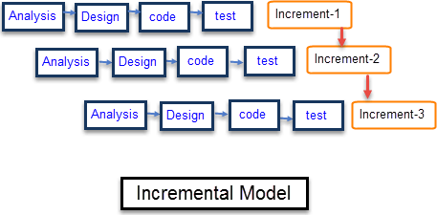

|  |  |
| --- | --- |
| Requirement Analysis | Requirement and specification of the software are collected |
| Design | Some high-end functions are designed during this stage |
| Code | Coding of software is done during this stage |
| Test | Once the system is deployed, it goes through the testing phase |

|  |  |
| --- | --- |
| **Advantages** | **Disadvantages** |
| * Software will be generated quickly during the software life cycle | * It requires a good planning designing |
| * It is flexible and less expensive to change requirements and scope | * Problems might cause due to system architecture as such not all requirements collected up front for the entire software life cycle |
| * Though the development stages changes can be done | * Each iteration phase is rigid and does not overlap each other |
| This model is less costly compared toothers | * Rectifying a problem in one unit requires correction in all the   Units. |

1. SYSTEM ANALYSIS

* **PRESENCE SYSTEM**
* **REQUIRMENT GATHERING & ANALYSIS**
* **SCOPE OF SYSTEM**
* **OBJECTIVES**

PRESENCE SYSTEM:

Software is always part of large system or business work beginnings by establishing requirement for all system elements and then allocating some subset of these requirements to software. This system view is essential when software must interface with other elements such as hardware, people and databases. System engineering and analysis encompasses requirements gathering at the business area level.

System study is most important stag of software development life cycle while attempting to convert the manual process to computerized process. System study can be carefully defined as “a study of the operations or a set of connected elements and of the inner connection between these elements”.

The process of building a system has been always complex. In recent years, however with the system becoming larger and costlier, the complexities have multiplied. So the need for better method for developing system is widely recognized. An applied model of the system should meet a few basic requirements:

The model should utilize established methods and techniques, for example, concepts such as database designs and structured programming.

The model should be structured and should cover the entire system development process from feasibility study to programming.

The model should consist of “building blocks” which will define task result and interfaces. The models should separate the logical system (the actual needs of the user) from the physical system (the system to be implemented)

Documentation should be a direct result of the development work and should be concise, precise and as non-redundant as possible.

Based on the above requirement of the system of the system model, system study was done. The study covered the overall functionality of the existing system was done by interviewing the personal involved and questionnaires distributed to them were they processed and studied sample document were collected as they would be of use during the design and implementation phases based on the results of system the requirements model was developed.

**REQUIRMENT ANALYSIS:**

User any system when supposed to be developed it is essential that the designer follows the step of software development life cycle (SDLC).

SDLC consists of various integrated steps all levels of software development SRS (System Requirement Analysis) is the first technique step in SDLC.

**REQUIREMENTS**

User Friendly.

All relevant information should be displayed on the screen.

Should provide easy hard copy.

Easy access to details.

Valuable statistical information should be available.

Timely reports should be generated.

Minimum mouse usage and maximum keyboard should be facilitated. ▪Graphical charts should be available.

**SYSTEM REQUIREMENT**

System and utility department of Fasttreack shop require a complete solution a computerize their product functionality. For this they want to maintain all details of the product coming for processing.

**FUNCTIONAL REQUIREMENTS:**

Function requirements meant the process to be performed by the system to achieve the desire output:

Output drives the inputs flow through the system.

Invalid inputs should be avoided and appropriate message will be displayed.

The data should have an easy and smooth flow through the system and the integrity of the data should maintain.

**DESIGN CONSTRAINTS:**

These are the facts present in client’s environment that many restrict the choice of a designer. Such factors include standards that must followed, resource limits, operating environment, reliability and security.

The reliability of the project depicts the extent to which it does not fail. The software should be bug free. Security is a must whenever a larger database is involved.

Some situations should be handled carefully.

**PERFORMANCE REQUIREMENTS:**

This part of SRS specifies the performance constraint on the software system.

There are two type of requirement they are:

**Static Requirement:**

Static requirement is those that do not impose constraint on the execution of the software but on the capability requirements of the system. This software is to be single user software. Terminal needed should be on only one. It should be easy to handle several files and normal sized databases.

**Dynamic Requirement:**

Dynamic requirement is those they specify constraints on the execution of the system. These include the response time and throughput constraint on the system. The response time should be minimum in order that the through put is high faster processing speed should support multi-user very little response time.

**External Interface Requirement:**

This refers to the screen design i.e. the user interface. The screen layout Should be attractive with the various controls well- spaced and compact. Standard Pertaining should be simple and attractive having catchy layouts and screen design.

**Coding Specifications option:**

In maintains and certain there should be for creation, changes and display in the create phase, a new entry is to be added to other. During the change desired and then edit the fields for which changes are inculpated. It will update in the respective table on the saving the information. During the display phase one has to select the key field for which the information is to be displayed. No modification is to be allowed in this phase.

1. Software Requirement specification

**4.1 ER (ENTITY RELATIONSHIP DIAGRAM):**

The Entity-Relationship (ER) model was originally proposed by Peter in 1976 as a way to unify the network and relational database views. Simply stated the ER model is a conceptual data model that views the real world as entities and relationships. A basic component of the model is the Entity-Relationship diagram which is used to visually represent data objects. It is simple and easy to understand with a minimum of training.

Therefore, the model can be used by the database designer to communication the design to the end user.

* **ER DIAGRAM:**

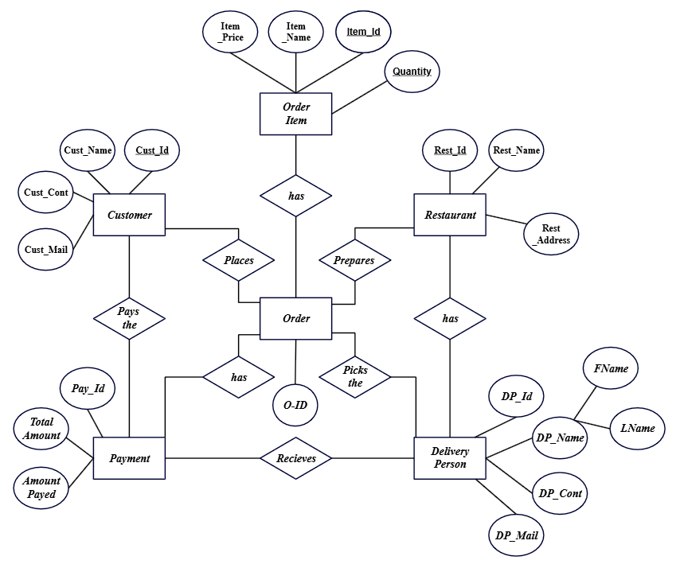

**4.2 SYSTEM FLOW DIAGRAM**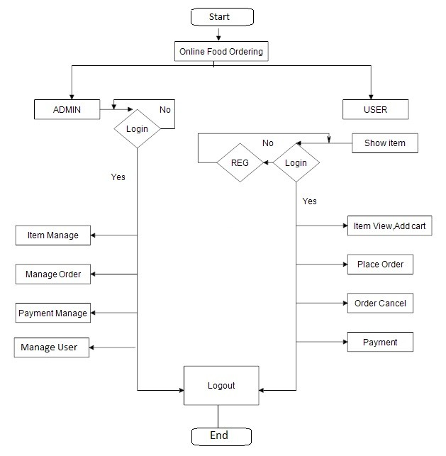

**4.3 DFD DIAGRAM:**

A data flow diagram is graphic representation of a system that shows data flows to from and within the system, processing function that change the data in same manner, and the storage of this data. They are networks of related system function that indicated from where information is revived and to where it is sent. An external entry is the originator or receiver of data or information.

**Zero Level:**

Level 0 is the highest-level Data Flow Diagram (DFD), which provides an overview of the entire system. It shows the major processes, data flows, and data stores in the system, without providing any details about the internal workings of these processes.

It is also known as a context diagram. It’s designed to be an abstraction view, showing the system as a single process with its relationship to external entities. It represents the entire system as a single bubble with input and output data indicated by incoming/outgoing arrows.

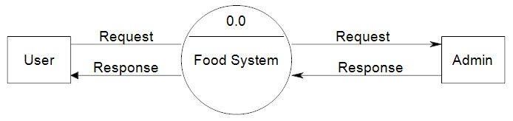

**Zero Level.**

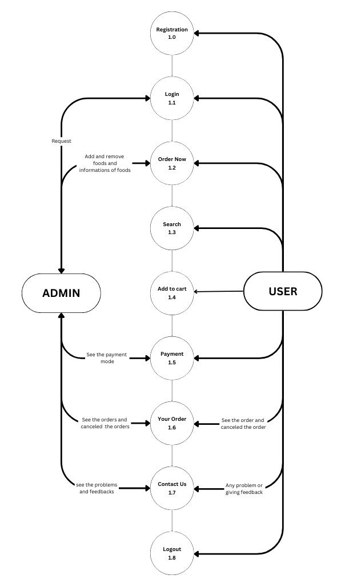 **First Level:**

1. Advantages of online food order

**Advantage of online food order:**

1. **Enhanced Customer Convenience:**
   * **Online Ordering**: Customers can place orders from the comfort of their homes, reducing wait times and improving overall satisfaction.
   * **Reservation System**: Allows customers to book tables in advance, ensuring they have a spot during peak hours.
2. **Increased Reach and Accessibility:**
   * **24/7 Availability**: The website is accessible at any time, allowing customers to browse the menu and place orders outside of regular business hours.
   * **Mobile-Friendly Design**: Ensures that the website is easily accessible on smartphones and tablets, catering to a wider audience.
3. **Improved Operational Efficiency:**
   * **Order Management**: Streamlines the order-taking process, reducing errors and improving kitchen efficiency.
   * **Customer Data**: Collects valuable customer data that can be used for targeted marketing and improving service offerings.
4. **Cost-Effective Solution:**
   * **Reduced Overhead**: Minimizes the need for additional staff to take orders over the phone.
   * **Marketing Savings**: Digital marketing through the website can be more cost-effective than traditional methods.
5. **Customer Engagement and Loyalty:**
   * **Feedback System**: Provides a platform for customers to leave reviews and feedback, helping to build trust and loyalty.
   * **Loyalty Programs**: Integrate loyalty programs to reward repeat customers, encouraging them to return.
6. **Scalability:**
   * **Easily Updatable**: The website can be easily updated with new menu items, promotions, and features without significant additional costs.
   * **Expansion Ready**: Can support the addition of new locations or services as the business
7. Screenshots

* **Home Page:**

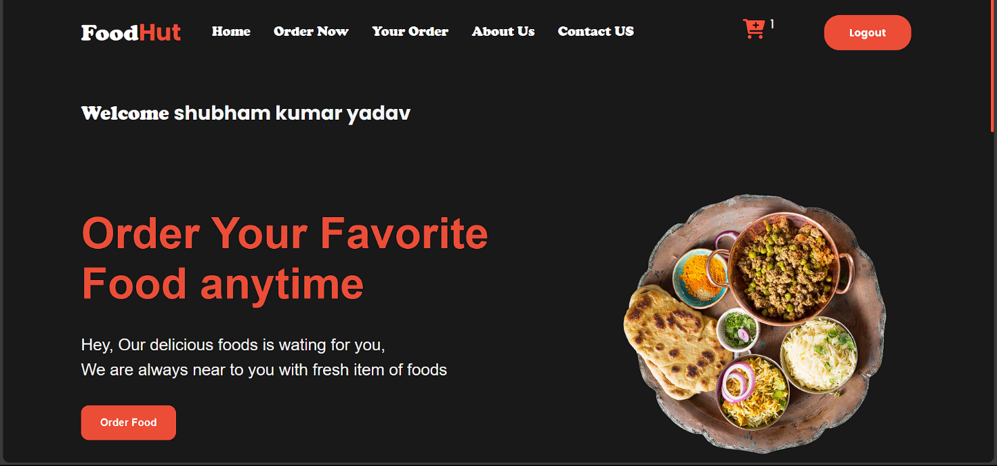

* 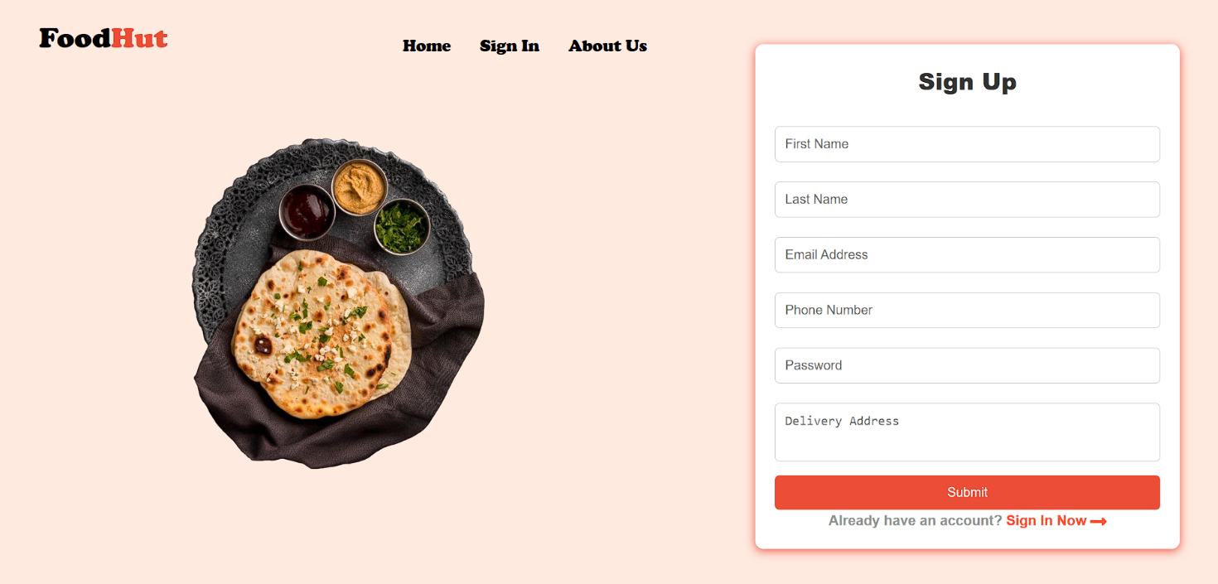**Signup Page:**
* **Login Page:**

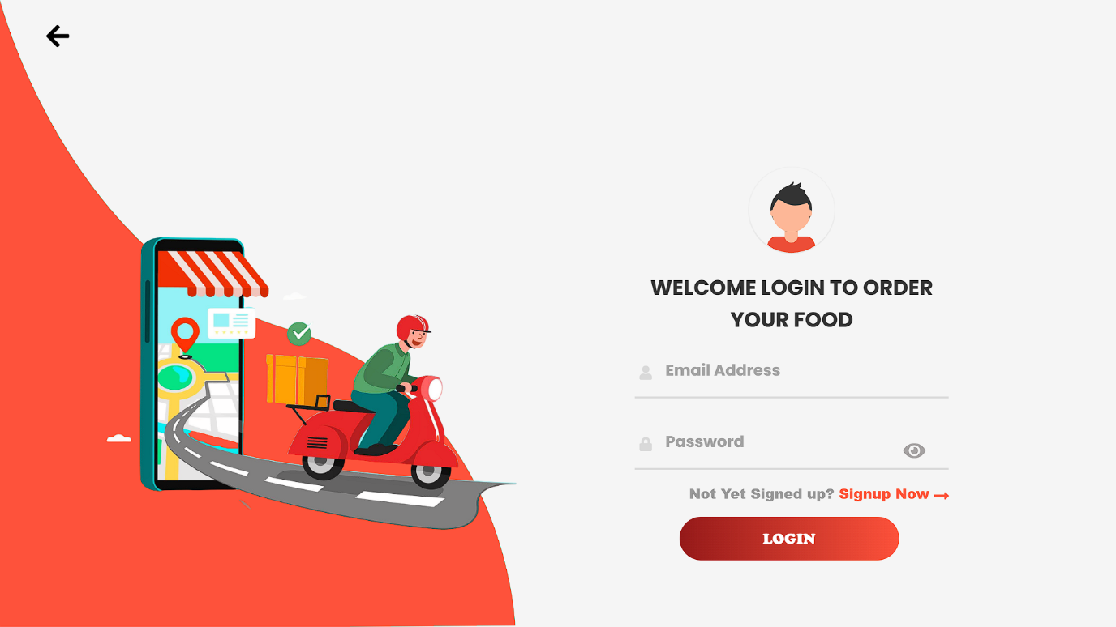

* 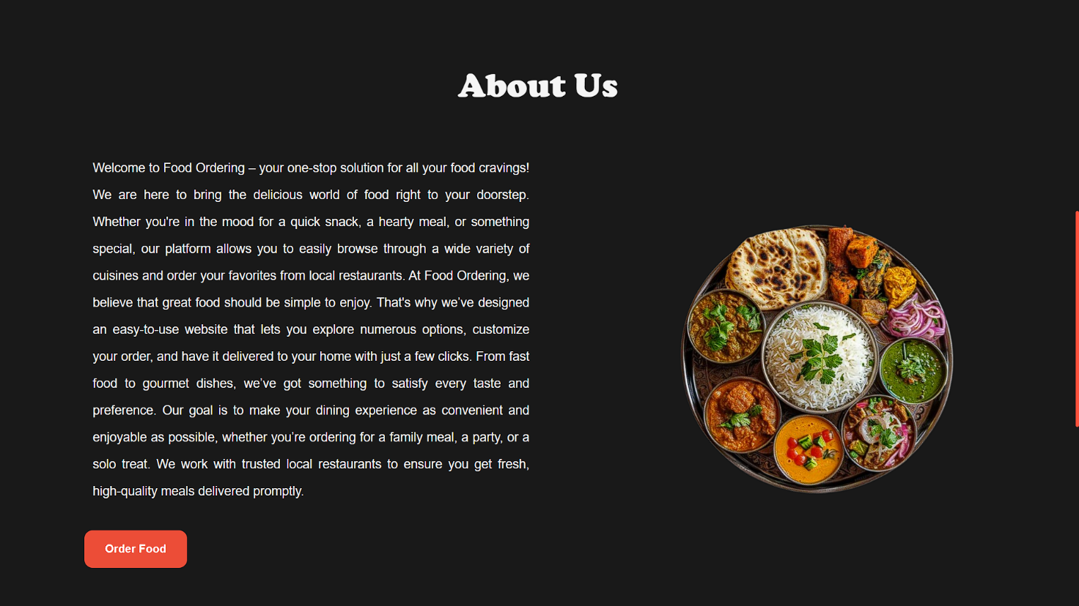**About Us:**
* 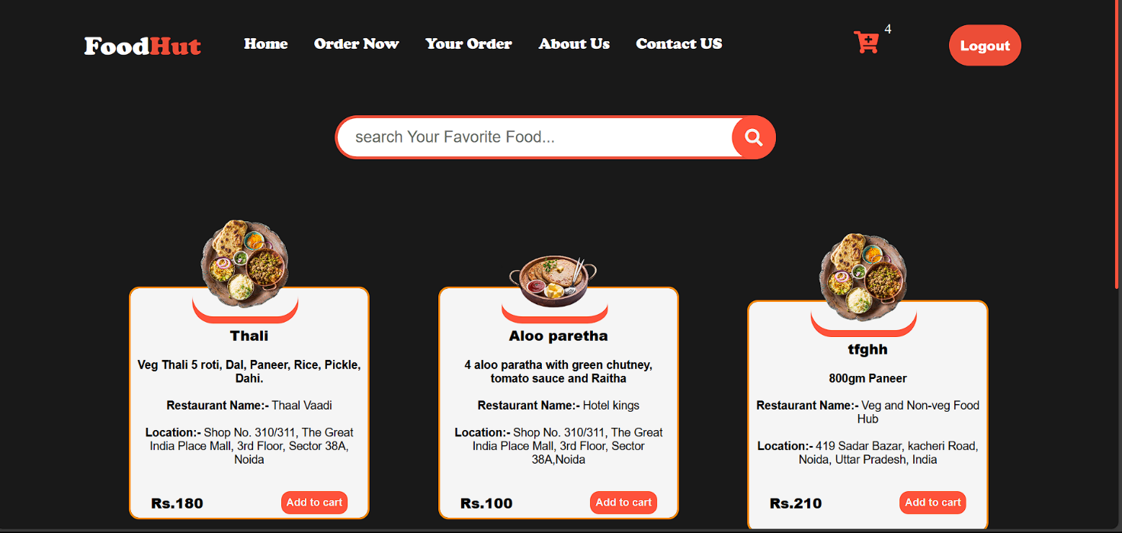**Order Now Page:**
* **Searching:**

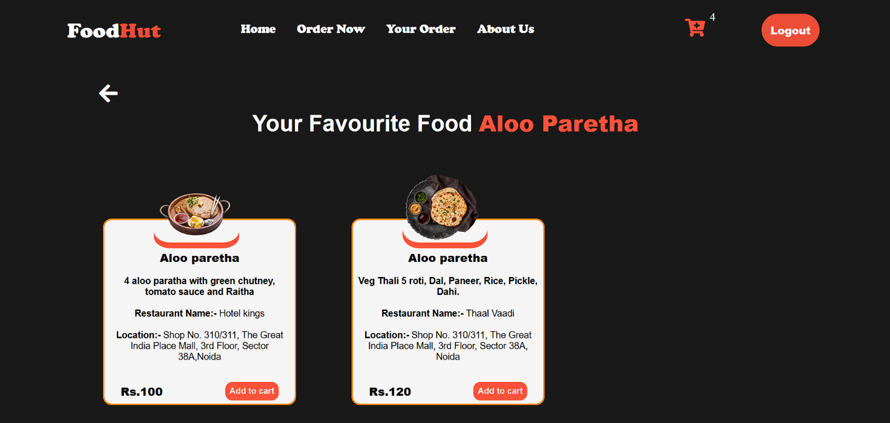

* **Add to Cart and Payment Mode:**
* 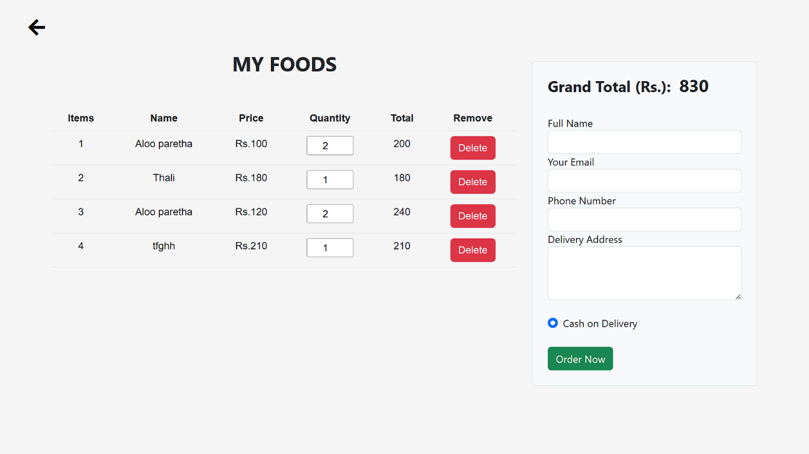**Footer:**

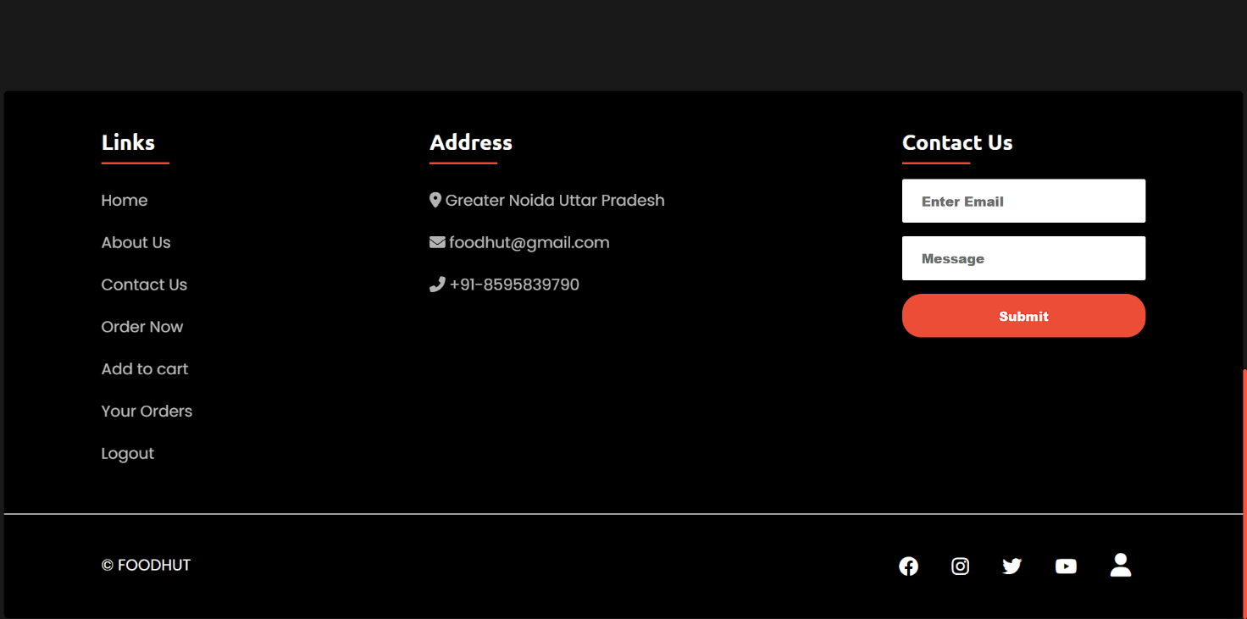

* 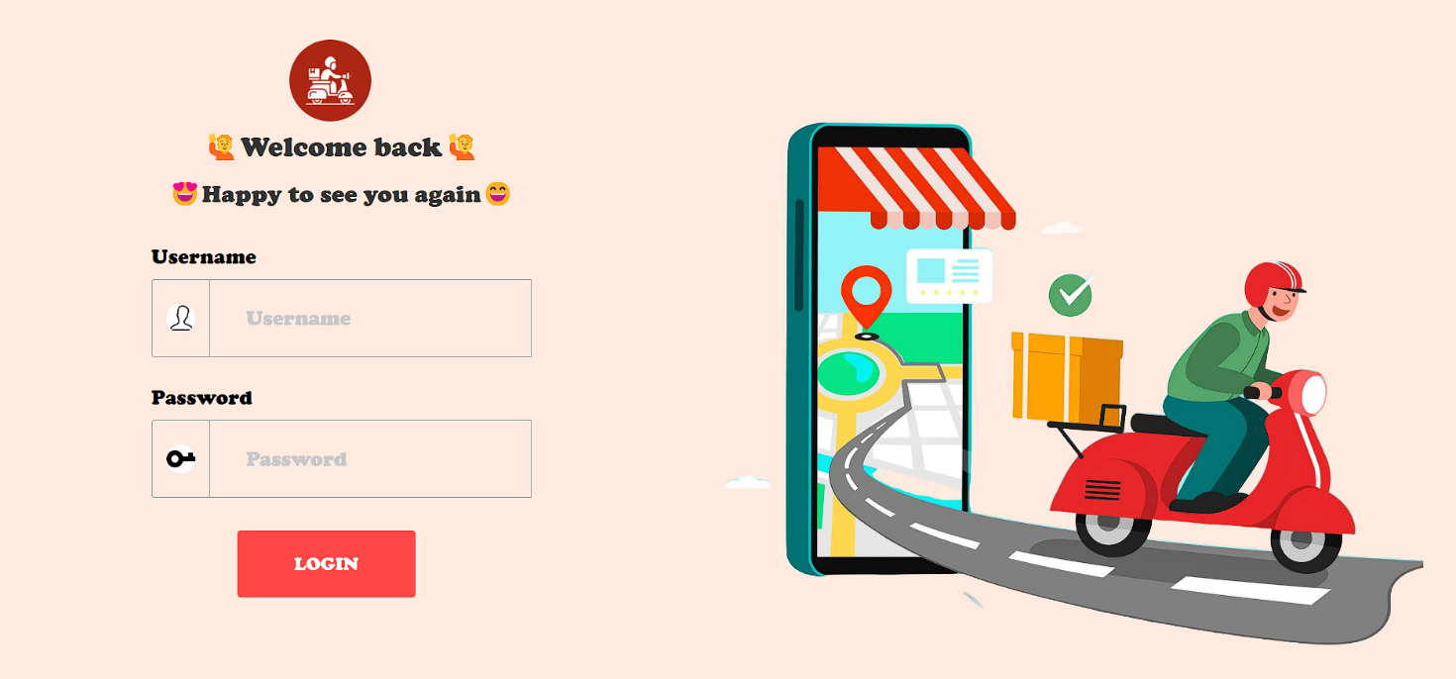**Admin Login Page:**
* 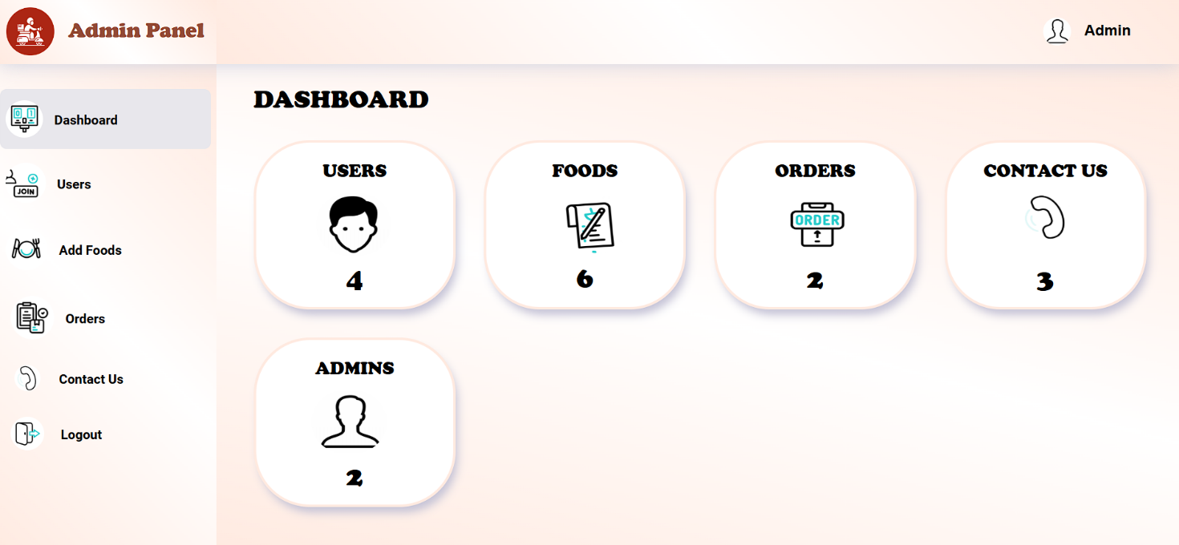**DASHBOARD Page:**
* 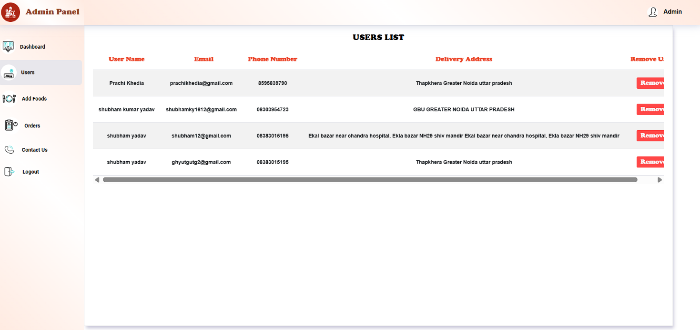**User List:**
* 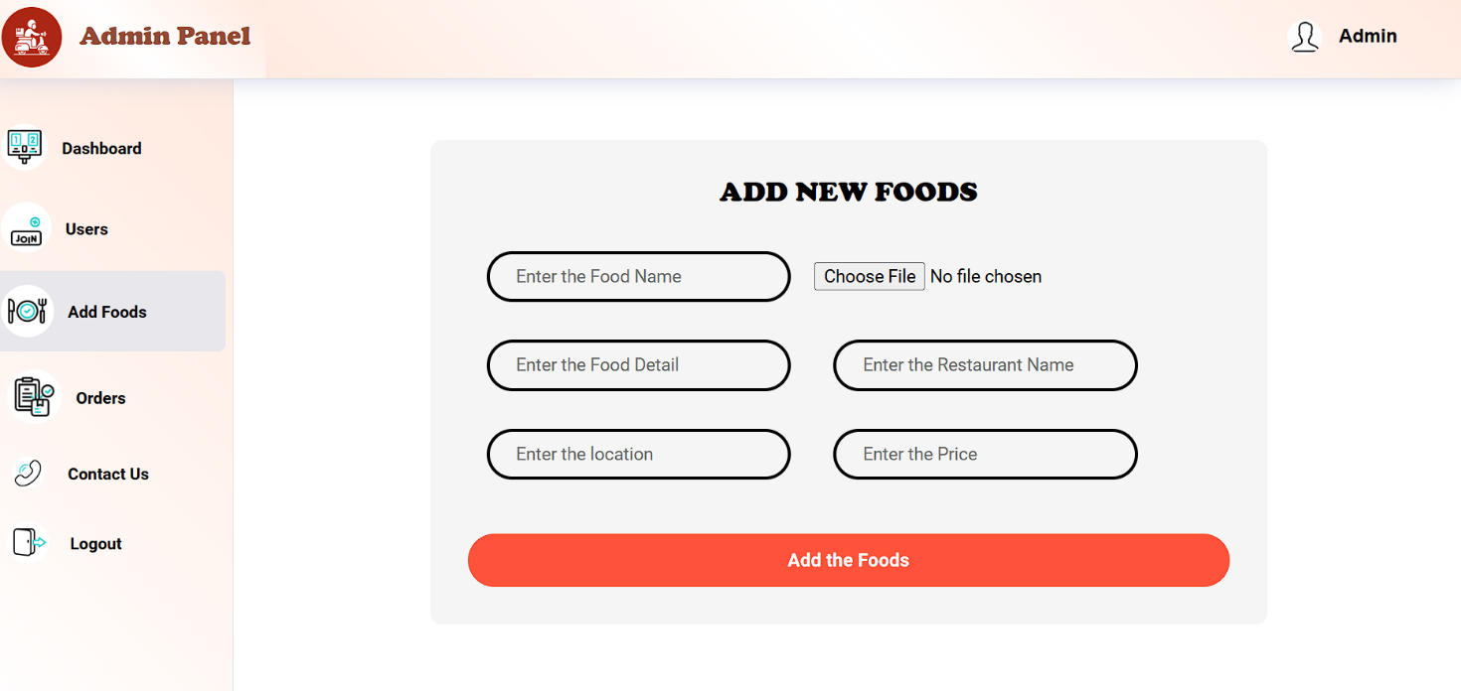**Add Food Page:**
* **Food List Page:**

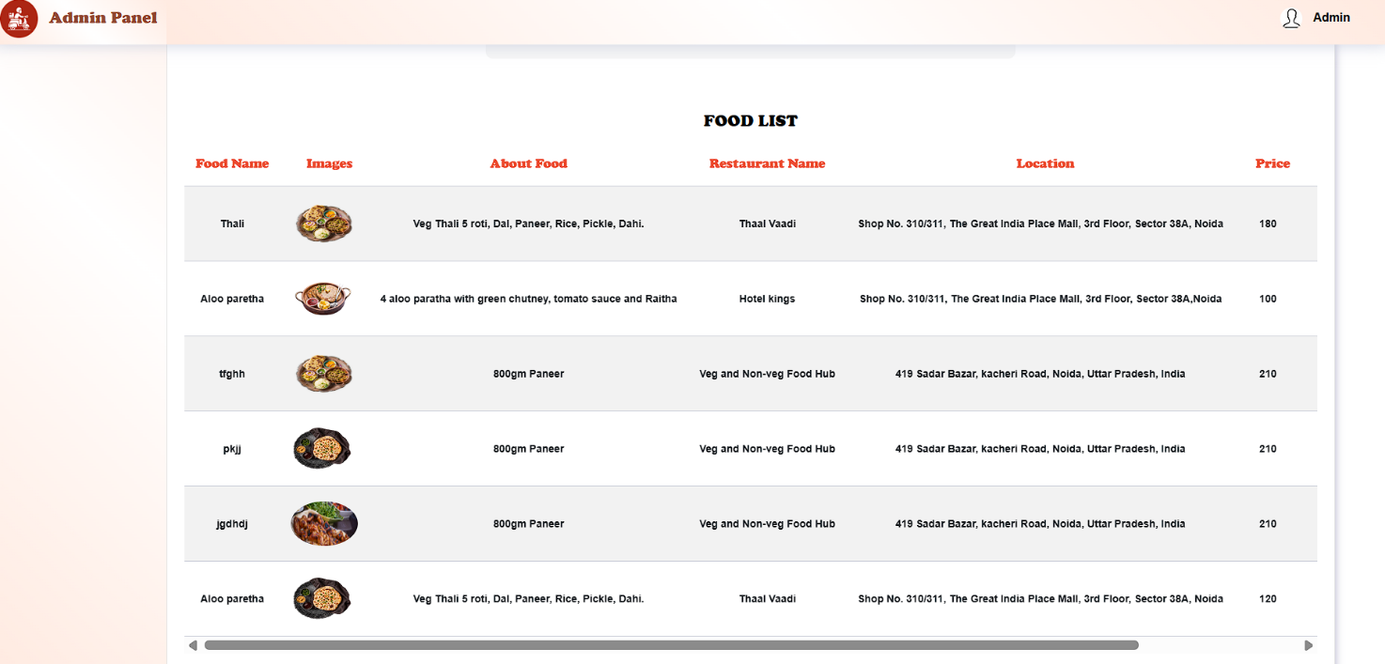

* **Orders List Page:**

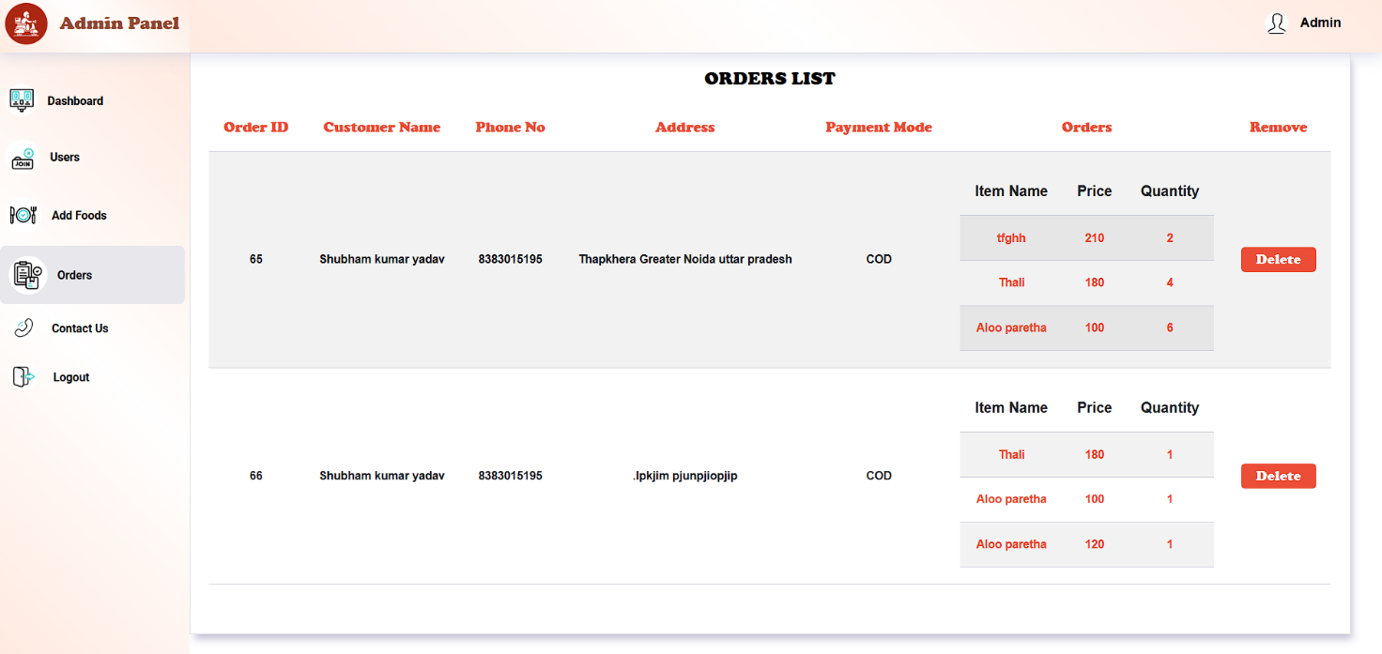

* **Change Admin Page:**

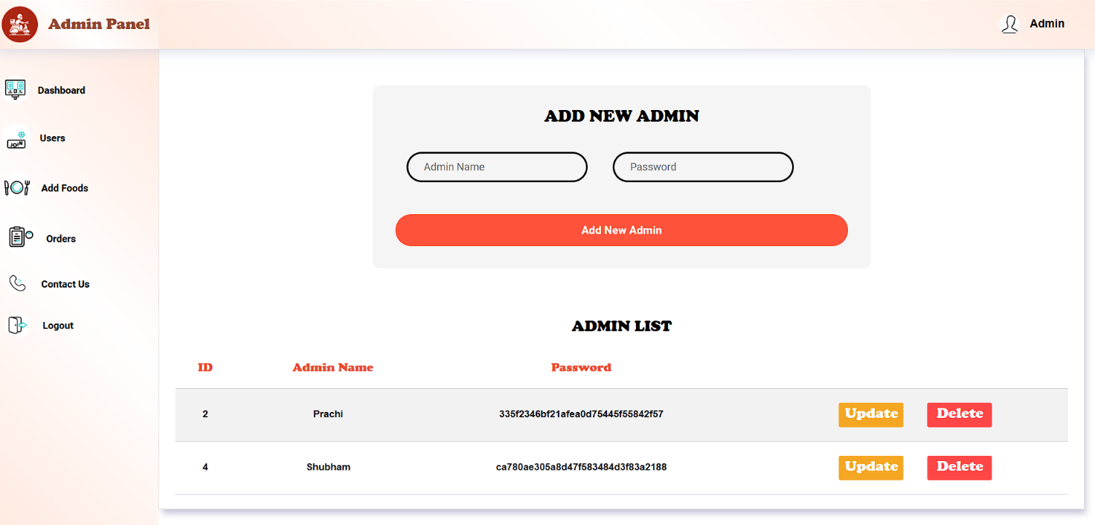

1. Conclusion

online food ordering serves as a vital platform that bridges the gap between consumers and restaurants, making it easier for users to explore diverse culinary options from the comfort of their homes. By leveraging user-friendly interfaces, secure payment gateways, and efficient order tracking systems, such platforms enhance the overall dining experience, providing convenience and accessibility.

The success of an online food ordering relies not only on technology but also on building strong partnerships with local restaurants and ensuring the highest standards of food quality and delivery services. As customer preferences evolve and the demand for food delivery continues to rise, investing in features like personalized recommendations, real-time updates, and customer support becomes crucial for retaining and expanding the user base.

Ultimately, a well-designed online food ordering can significantly enhance customer satisfaction while driving growth and profitability for restaurants, positioning itself as an indispensable tool in today’s fast-paced food industry.

Overall, online food ordering helps connect customers with delicious food in a quick and easy way.

1. Future scope
2. **Personalization and AI**: Leveraging AI to provide personalized recommendations based on user preferences, past orders, and dietary restrictions. This could enhance customer experience and increase order frequency.
3. **Voice Ordering**: As voice assistants become more prevalent, integrating voice-activated ordering could streamline the process and cater to hands-free users.
4. **Health and Wellness Focus**: Providing nutritional information and meal planning options for specific dietary needs (e.g., keto, vegan) can tap into the health-conscious market.
5. **Real-time Tracking and Transparency**: Offering real-time order tracking and transparent communication about food sourcing and preparation can build trust and enhance customer satisfaction.
6. **Global Expansion**: As internet penetration increases in developing regions, expanding services to these markets presents significant growth opportunities.
7. **Enhanced Delivery Options**: Incorporating drones and autonomous vehicles for delivery can speed up the process and reduce costs.
8. **Integration with Social Media**: Allowing users to share their orders and reviews on social media can enhance brand visibility and attract new customers.
9. References

* [**https://en.wikipedia.org/wiki/Online_food_ordering**](https://en.wikipedia.org/wiki/Online_food_ordering)
* [**https://en.wikipedia.org/wiki/Food_delivery**](https://en.wikipedia.org/wiki/Food_delivery)
* [**https://www.zomato.com/**](https://www.zomato.com/)
* [**https://www.swiggy.com/**](https://www.swiggy.com/)
* [**https://www.w3schools.com/php/default.asp**](https://www.w3schools.com/php/default.asp)
* [**https://www.mysql.com/products/community/**](https://www.mysql.com/products/community/)